COMPLETE WOODSHOP LIQUIDATION (Absolute)
LOCATION: 7087 S. Kohler Rd. Apple Creek Oh. 44606. Located on Kohler Rd. south of US 250, midway between Apple Creek and Mt Eaton. Signs will be Posted.
Thursday Dec. 12th at 10:00 A.M.
• Complete Hydraulic Set Up • Blower System W/Return Air • Complete Finish Room W/Booth and Guns
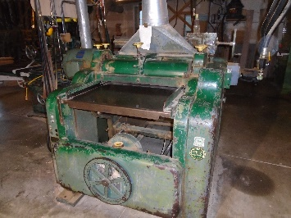
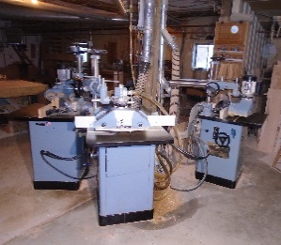
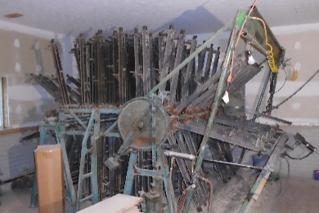
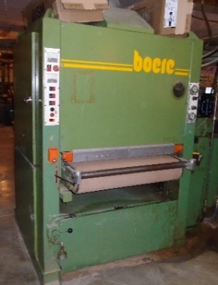
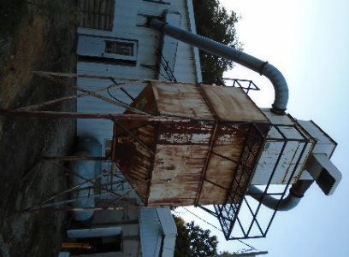

Taylor Clamp Carrier Delta 3 Shaper Setup Buss Spiral Cutter Planer
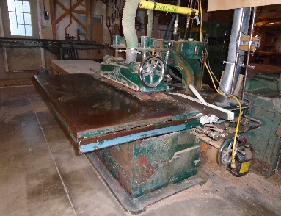
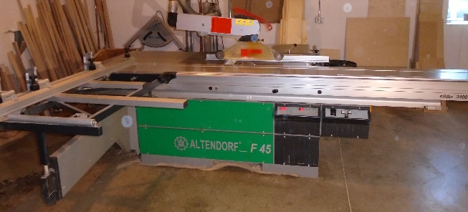

Dust Collection System Boere Wide Belt Sander
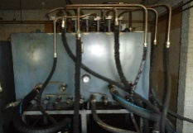
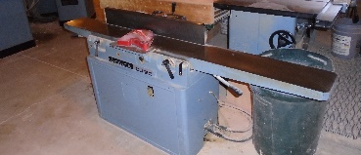

Delta DJ20 8” Jointer Hyd Setup Diehl 55 Straightline Rip Altendorf F45 Sliding Table Saw
Dust collector system and baghouse w/shaker, 14” inlet, sawdust bin, 5,000 cfm w/return air, hyd. powered; Complete hyd. setup w/8 pumps, 2 tanks, driven w/60 hp electric motor includes 15 hp Saylor Beall compressor and 108 amp charger; Allis Chambers ACE50LCR snDAE103182 battery forklift, 36v, 3300 lb. lift w/54” forks; Shop Tools; Altendorf F45 sliding table saw, hyd. w/up down & tilt blade on 110v, extra miter fence, original electric motors sell separately; Delta 10” unisaw, hyd. powered; Taylor 25 section clamp carrier, 32” clamps, 6 clamps per section, 5 additional sections available, 7.5’ wide, air tightener, air flattener, air gate; Glue conveyor 15” wide 11 foot long, air powered; Boere heavy duty 36” double head wide belt sander, 1st head rubber drum, 2nd head platinum, shoe holddowns, air tracking, air up/down table, hyd. power & feed, model TKS900 sn84013011; Buss 30” shear spiral cutterhead planer, 8” max opening, hyd. power & feed, air manual table up/down, model 66 sn6526; Diehl 55 straight line ripsaw, hyd. powered, sn10218, glue line accuracy; Delta 8” DJ20 jointer, hyd; Whirlwind 212L 18” upcut saw, hyd. powered w/air stroke, 8’ infeed & outfeed tables, including fence w/stops; 2 Delta 43-370 shapers, 1” spindle using 1 ¼” cutters w/spacers, hyd. powered; 2 Delta 43-375 shapers, ¾” spindle, hyd. powered; 3 Delta 3 roll power feeds, 220v, 1 ph,; 1 Delta 3 roll power feed, air powered; shaper cutters and accessories; Coping shaper w/coping sled, ¾” spindle, 220v, 1 ph,; Hinge notching machine, 110v, foot pedal operated; Door/frame clamp 5’ x 8’ w/6 clamping cylinders; Silver Doweller, 2 spindle, air powered; 2 MC300ST Omga chopsaws w/stand & fence, 220v, 1 ph.; wall mount air powered sanding drum; 2 MVM pocket hole machines, air powered; Weaver 11 spindle line boring machine, 115v w/sliding table; Edge sander, 6” x 129”, 220v, w/extra belts; Sand Pro 31” x 48” downdraft table, 110v; Sand Pro 36” x 72” downdraft table, 110v; 2 Porter Cable 5116 Omnijigs, air operated; Custom made drawer front knob drill, air; Mike Jecky cutoff saw w/table & fences, air powered; Delta bench top drill press, 110v; Delta 14” bandsaw, 110v; Powermatic 719 Chisel mortiser, 110v; 100 Pony clamps; Sanding booth, 6’ x 8’ hi; 36” inspection lights, 110v; 3 shop fans; Shopmate 6” bench grinder; Racking, shelving & finish racks on casters; Lots of sanders, drills, routers, router bits, nailers in Dewalt, Dynabrade, 3M, Ekasand, Sioux, Bosch, Senco, Porter Cable and more; Furniture dollies and lumber carts; 2 air misters; 2 - 500 gallon air tanks; Lots of misc. lumber; Finish Room; Spray booth, 8ft x 16ft w/lights w/36” hyd. powered fan; Powermatic air make up unit, natural gas, w/ hyd. powered fan; Kremlin 17A N serie 74398 pump w/Kremlin MVX spray gun; Stain pump w/Binks spray gun;
AUCTIONEER NOTE: This is a complete liquidation of 250 woodworking shop and will include a nice lineup of air, hydraulic & electric powered tools and equipment. Finish shop was not in production in the last year.
AUCTION TERMS: Cash, Check, Credit Card w/valid ID. There will be a 10% buyer’s premium Air Works Auction Company
on-site with an additional 3% for all credit card purchases. All items are sold “as is, where is PO Box 242 Kidron Oh 44636
with no warranty expressed or implied. Office 330-749-4362
Auctioneer Dan Troyer 330-749-9478 office@airworksauction.com
Auctioneer Eli Troyer 330-317-9259 www.airworksauction.com
